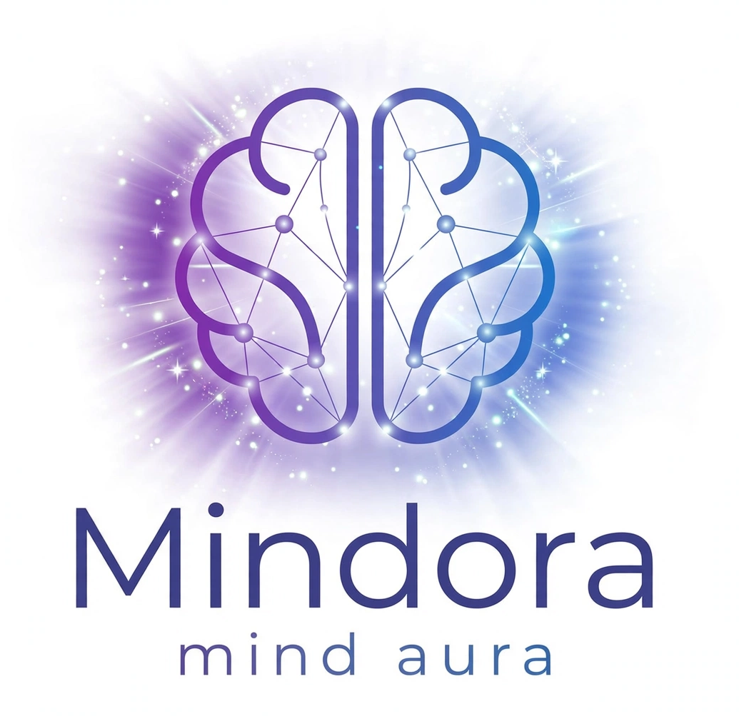

MINDORA = MIND + AURA = Zehan ki Roshni ✨
Mindora is a premium magical learning ecosystem for kids. We are not a boring tuition app. We are Dimagh ki Roshni.
Tagline: Light Up Your Mind
Urdu Tagline: Zehan Roshan, Mustaqbil Roshan

For Homepage Hero Banner:
Light Up Your Mind with Mindora
Where learning feels like magic. Mindora turns math, logic, and memory into magical adventures for kids aged 4-12. Because every child has a glowing aura of genius waiting to shine.
What is Mindora?
Mindora is built on one simple belief: Every child is born with a brilliant aura.
We combine Neuroscience + Gamification + Storytelling to create brain games that don't feel like studying.
For Kids: It feels like playing in a magical universe.
For Parents: It builds IQ, Focus, Memory, and Math skills — screen time you can be proud of.
Our Mission: To make 10 million kids in Pakistan and beyond fall in love with learning.
Our Vision: To be the Pandora of Education — a magical box full of knowledge.
For How It Works (3 Steps):
PLAY: Kids play Brain Games, Math Quests, Memory Match GLOW: Their Mind Aura grows brighter with every level SHINE: Parents see real progress in focus and grades.
✨ Mind + Aura = Zehan ki Roshni
🧠 Magical Brain Games for Kids 6-11
💜 Learning that Feels Like Magic
Zehan ki Roshni ✨ | Brain Games That Actually Make Kids Smarter | Math + Memory + Magic

What does MINDORA mean? 👇
MIND = Zehan
ORA = Roshni / Noor / Magical Energy
So Mindora = The Light of the Mind.
We are not here to give your kids more homework. We are here to make their mind GLOW. ✨

